Kubernetes with Containers and DevOps Workshop

Hands-on lab step-by-step

Aralık 2018

9.Upgrade an Azure Kubernetes Service (AKS) cluster

Azure Container Service (AKS) makes it easy to perform common management tasks including upgrading Kubernetes clusters.

**Upgrade an AKS cluster**

Before upgrading a cluster, use the az aks get-versions command to check which Kubernetes releases are available for upgrade.

az aks get-versions --location westeurope --output table

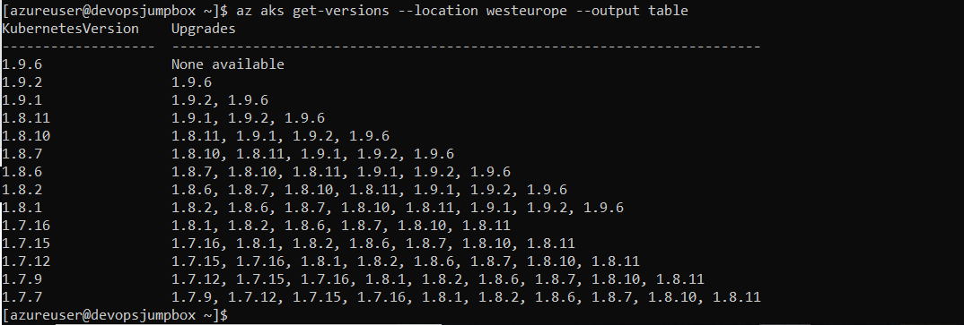

AKS_CLUSTER_NAME=devopsaks

RESOURCE_GROUP_NAME=mstrdevopsaks-rg

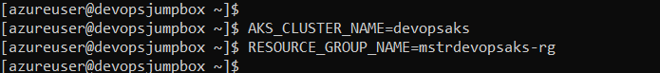

az aks scale -g $RESOURCE_GROUP_NAME -n $AKS_CLUSTER_NAME --node-count 2

az aks upgrade --name $AKS_CLUSTER_NAME --resource-group $RESOURCE_GROUP_NAME --kubernetes-version 1.10.5

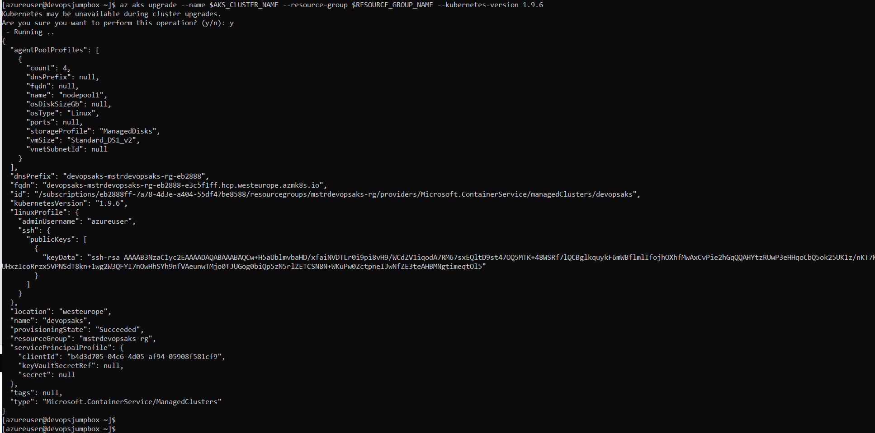

You can now confirm the upgrade was successful with the az aks show command.

az aks show --name $AKS_CLUSTER_NAME --resource-group $RESOURCE_GROUP_NAME --output table

